**Application-Load-Balancer: (Migrate your Classic Load Balancer to an Application Load Balancer)**

**Launch the 3 EC2 Instances :**

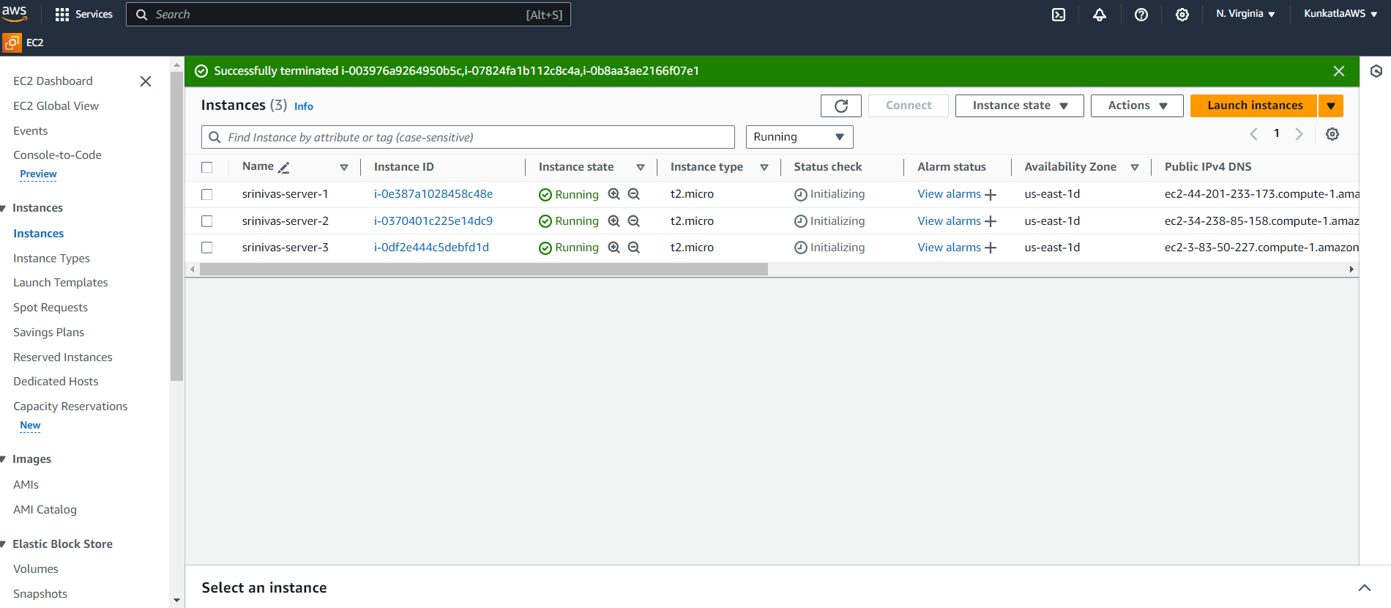

**Web Pages Runing:**



**Create Classic Load Balancer:**

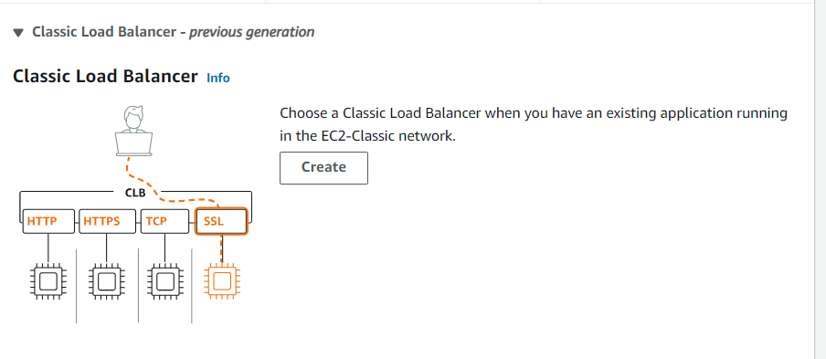

Basic configuration:

(Load balancer name 🡪 Scheme 🡪 Network Mapping (VPC and AZ’s) 🡪 add Security Groups 🡪Listeners and routing 🡪Add available Instances )

Now we verify the Summary section like below:

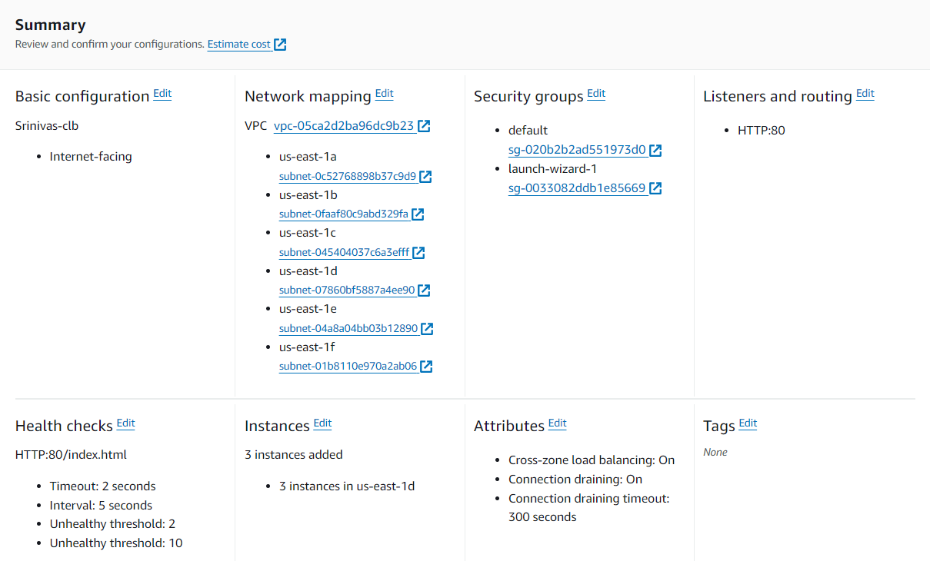

**Successfully Launched Classic Load Balancer:**

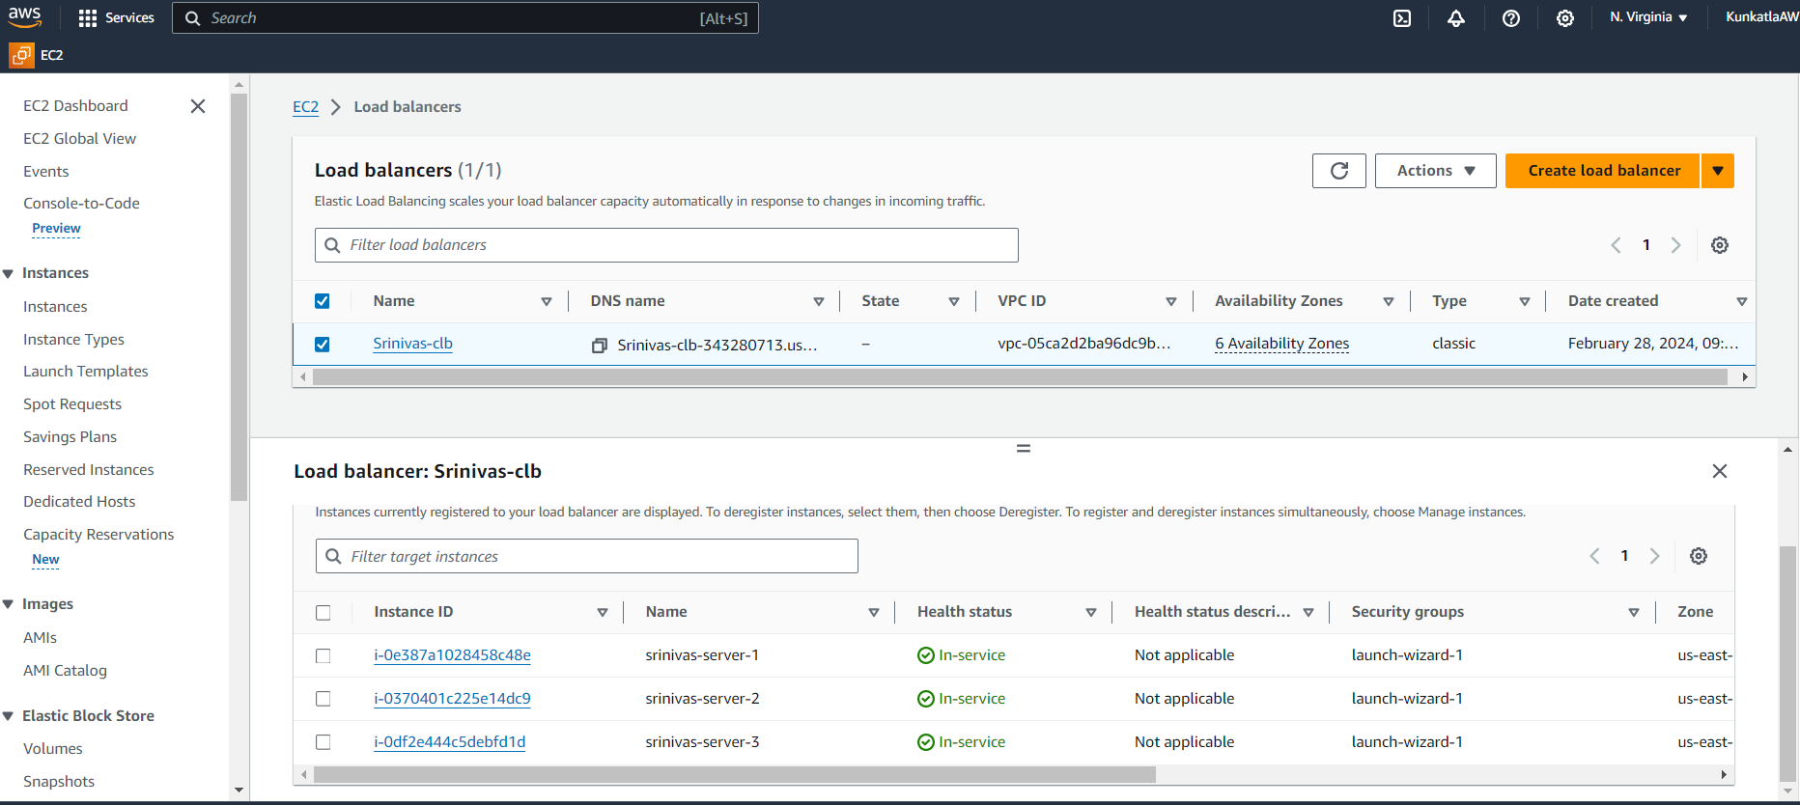

**Migrate to Application Load Balancer:**

(Migrate your Classic Load Balancer to an Application Load Balancer)

🡪 Find the below picture we have both Classic and Application Load Balancers

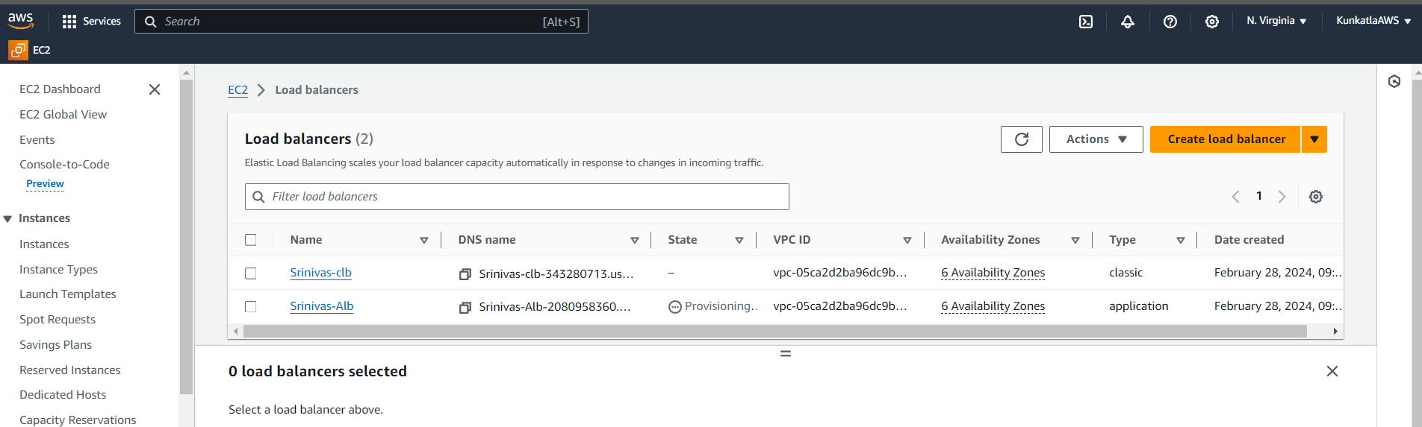

**Application Load Balancer**: The Application Load Balancer distributes incoming traffic HTTP and HTTPS traffic across multiple targets such as Amazon EC2 Instances, Microservices and Containers.

🡪Load Balancer we have something load balancing algorithm that is “Round Robbin”

🡪**Round Robbin :** Routes the traffic evenly across healthy targets in a sequential order.

-------***********--------

**Autoscaling:(** **To create an Auto Scaling group with 1 minimum and 3 maximum instances)**

**Create EC2 Instance:**

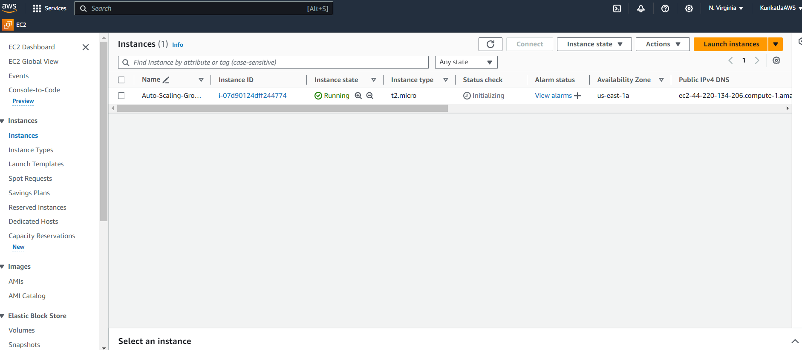

**Creating Image (AMI)**

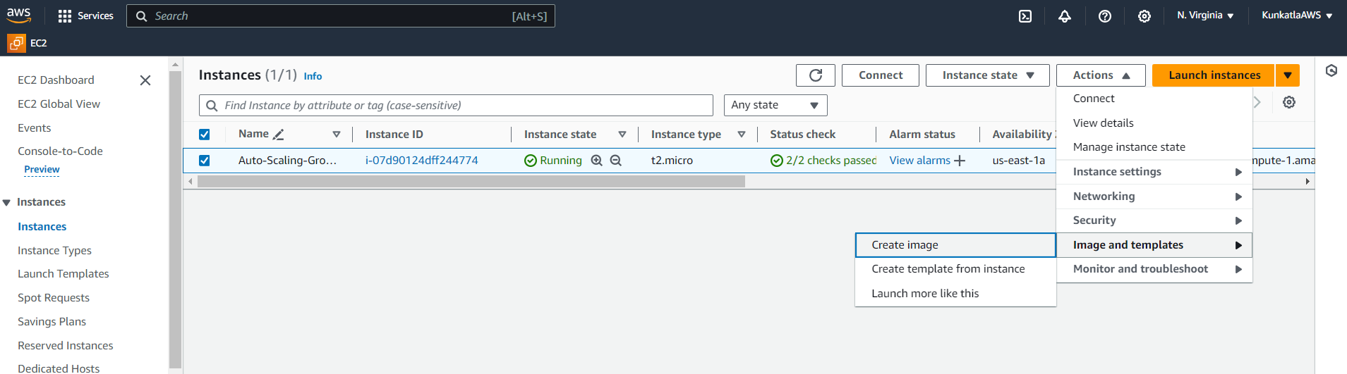

**Currently creating AMI**[**ami-0cb638d9ad4b7ba3d**](https://us-east-1.console.aws.amazon.com/ec2/v2/home?region=us-east-1#Images:visibility=owned-by-me;imageId=ami-0cb638d9ad4b7ba3d)**from instance i-07d90124dff244774. Check that the AMI status is 'Available' before deleting the instance or carrying out other actions related to this AMI.**

**Launch Template:**

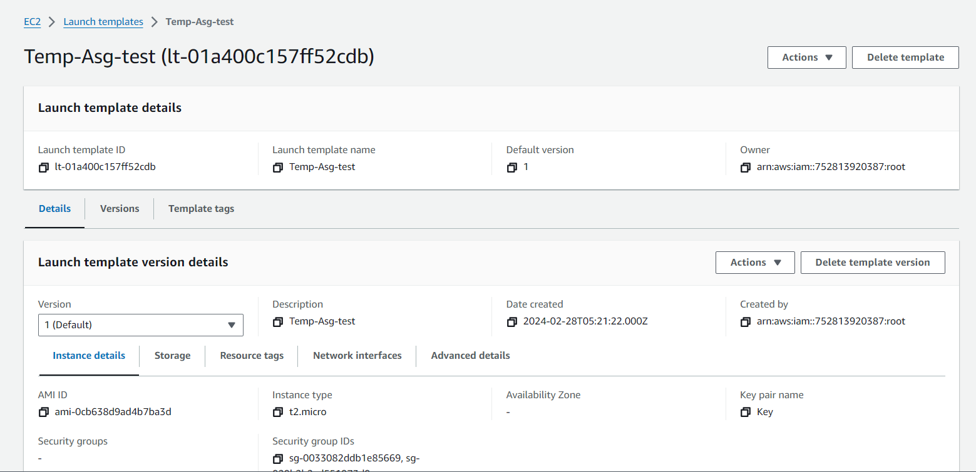

**Create Auto Scaling group:**

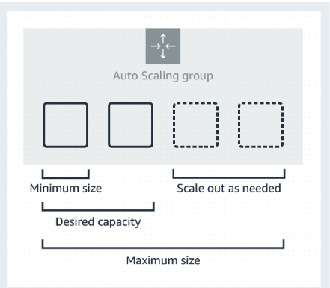

Choose Launch template 🡪 Auto Scaling group name 🡪 Launch template 🡪click next 🡪 Choose the VPC that defines the virtual network for your Auto Scaling group 🡪 Define which Availability Zones and subnets your Auto Scaling group can use in the chosen VPC 🡪 click next

Configure advanced options*:*

* Attach to an existing load balancer
* Enable Health Checks

Configure group size and scaling:

Desired capacity type 🡪 Desired capacity = 2

Scaling limits 🡪 Min desired capacity = 1 ; Max desired capacity = 3

**Review**

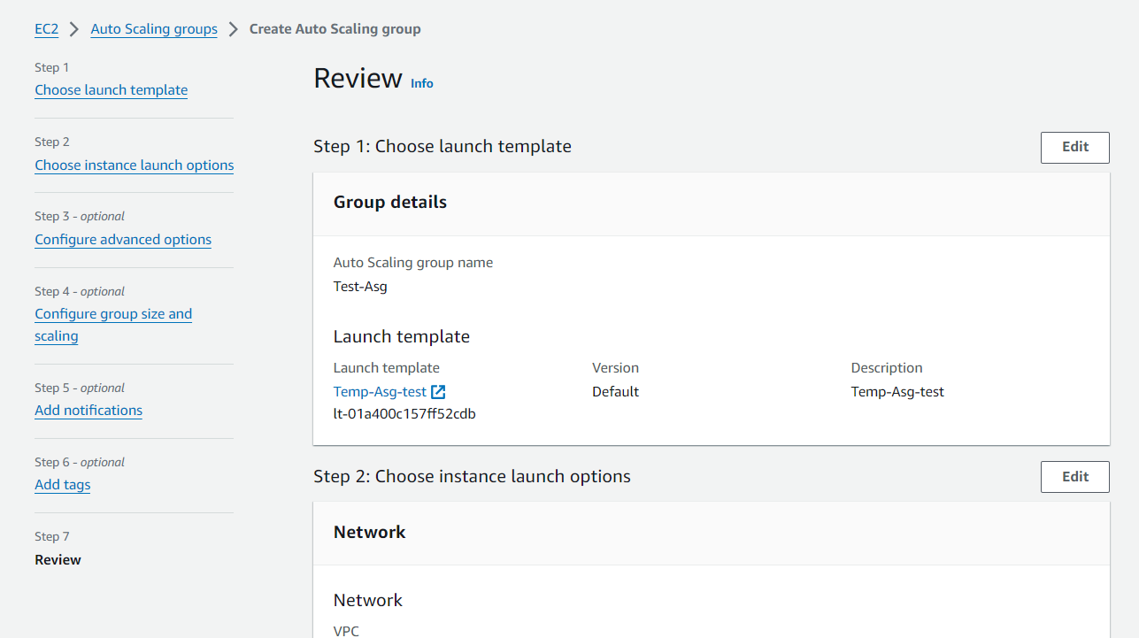

**created an Auto Scaling group with 1 minimum and 3 maximum instances :**

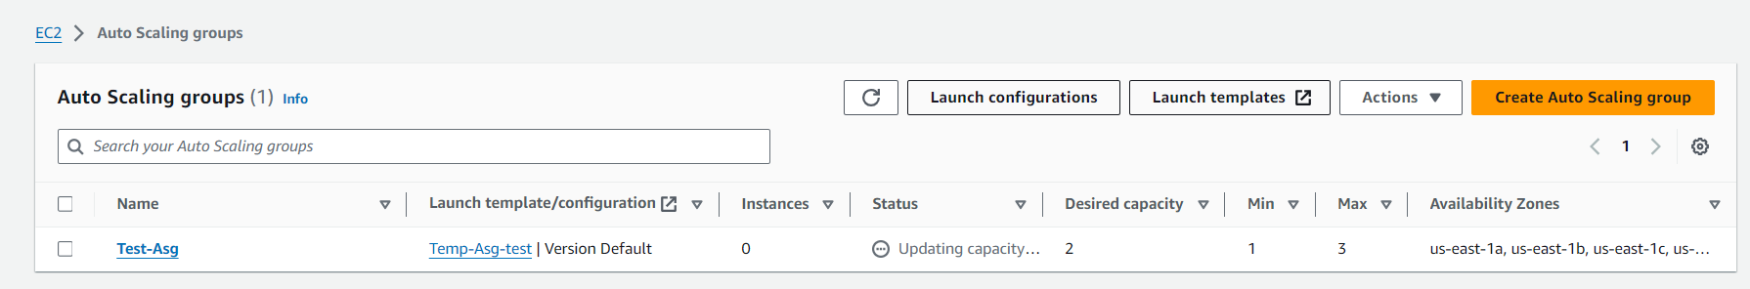

**Check the Instances Status which are created under Auto Scaling**



